# 2.2 Functional Requirements Specification

This section outlines the use cases for each of the activities users of the system separately. The user and the administrator of the NavUP both have use cases.

2.2.1 User Use Cases

Use case: **Get Current Location**

**Diagram:**

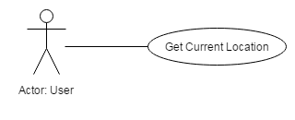

**Brief Description**

The user accesses the NavUP application, and checks his current location on campus using the app.

**Actor-System Interaction Model:**

|  |  |  |
| --- | --- | --- |
| **Actor: User** | **System: NavUP** | |
| **Pre-condition:** User has accessed the NavUP app | |  |
|  | 1. The NavUP displays the main window. | |
| 1. User clicks the Get Current Location button on the main menu. | 1. The system displays the user’s current location. | |
| **Post-condition:** None | |  |

Use case: **Get Directions**

**Diagram:**

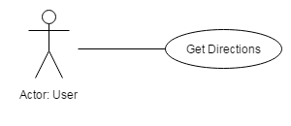

**Brief Description**

The user accesses the NavUP application and checks for directions to a specific location on campus.

**Actor-System Interaction Model:**

|  |  |  |
| --- | --- | --- |
| **Actor: User** | **System: NavUP** | |
| **Pre-condition:** User has accessed the NavUP app | |  |
|  | 1. The NavUP displays the main window. | |
| 1. The User clicks the Get Directions button on the main menu. | 1. The system prompts the user for his current location. | |
| 1. The user enters their current location. | 1. The system prompts user for destination. | |
| 1. User enters destination. | 1. The system displays the route and directions to destination. | |
| **Post-condition:** None | |  |

Use Case: **Search**

**Diagram**:

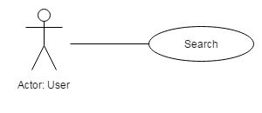

**Brief Description**

User accesses the NavUP system and searches for a venue that is on campus.

**Actor-System Interaction Model:**

|  |  |  |
| --- | --- | --- |
| **Actor: User** | **System: NavUP** | |
| **Pre-condition:** User has accessed the NavUP app | |  |
|  | 1. The NavUP displays the main window. | |
| 1. The user clicks the Search button | 1. The system displays search tab user must use to type name of venue. | |
| 1. The user types in the name of the venue and clicks the OK button to confirm search. | 1. The System (searches for venue on the database and) displays search results for user to choose from. | |
| 1. User picks the desired venue | 1. The system displays venue information and option to show directions. | |
| 1. User clicks the Show Direction button. |  | |
| **Post-condition:** User is shown the route he must take to get to the destination. | |  |

Use case**: Drop Pin**

**Diagram:**

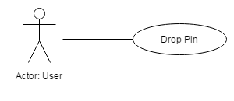

**Brief Description**

When User drops pin on a location, information on that location is saved.

**Actor-System Interaction Model:**

|  |  |  |
| --- | --- | --- |
| **Actor: User** | **System: NavUP** | |
| **Pre-condition**: User has accessed the NavUP application. | |  |
|  | 1. System displays the main window. | |
| 1. User drops pin on the map. | 1. System prompts the user asking if user wants to save the location. | |
| 1. User clicks the yes button to save location. | 1. System notifies user that the location has been saved. | |
| **Post-condition:** location is saved on the users phone. | |  |

Use Case: **Points of Interest**

**Diagram:**

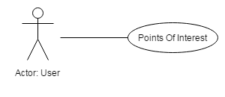

**Brief Description**

User checks for places that might be of interest to them.

**Actor-System Interaction Model:**

|  |  |  |
| --- | --- | --- |
| **Actor: User** | **System: NavUP** | |
| **Pre-condition**: User has opened the NavUP application, and the user has updated their profile in such that a way that the system can make suggestions about places the user might like. | |  |
|  | 1. System displays the main window | |
| 1. User clicks Points of Interest button. | 1. System (uses user’s profile to search and) displays list of points of interests to user. | |
| 1. User chooses from list. | 1. System displays information on option chosen from list and asks user if he wants directions to the point of interest. | |
| 1. User clicks yes button for directions or no to go back to list. |  | |
| **Post-condition: None** | |  |

Use case: **Get Information**

**Diagram:**

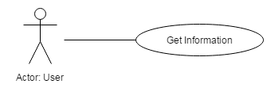

**Brief Description**

User clicks Get Information button and is shown information about a specific venue.

**Actor-System Interaction Model:**

|  |  |  |
| --- | --- | --- |
| **Actor: User** | **System: NavUP** | |
| Pre-condition: User has searched for a location and system displays the Get Information button and Get Direction button. | |  |
| 1. User clicks on Get Information button. | 1. System displays the information on the venue. | |
| **Post-condition**: None | |  |

Use case: **Get ETA (Estimated Time of Arrival)**

**Diagram:**

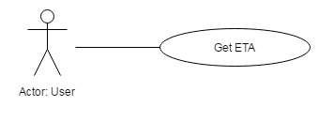

**Brief Description**

User is given the time it will take them to get to the destination.

**Actor-System Interaction Model:**

|  |  |  |
| --- | --- | --- |
| **Actor: User** | **System: NavUP** | |
| **Pre-condition:** User has found directions of destination he is looking and the system has displayed the results and the ETA button on the screen. | | |
| 1. User clicks on the ETA button. | 1. The system (calculates the results using current location and destination) displays the results of the calculation to the user. | |
| 1. User sees results and clicks OK. |  | |
| **Post-condition:** User is taken back to window where the route to destination is displayed. | |  |

Use case: **Choose preferred route**

**Diagram:**

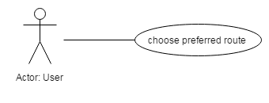

**Brief Description**

User is given options to choose from, each with a different route to get to the same destination.

**Actor-System Interaction Model:**

|  |  |  |
| --- | --- | --- |
| **Actor: User** | **System: NavUP** | |
| **Pre-condition:** User has searched, or pressed the Get directions button and now is given options to choose from. The options are :Most optimal Route, Less Crowded and Disability Friendly. | |  |
| 1. User chooses from the options on the screen. | 1. System displays results on the screen. | |
| **Post-condition:** User is directed to destination using preferred route. | |  |

* + 1. Administrator Use Cases

Use case: **R.E.A.D (Review, Edit, Add, and Delete) venue information**

**Diagram:**

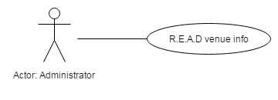

**Brief Description**

Administrator can Review, Edit, Add and Delete venue information

**Actor-System Interaction Model:**

|  |  |  |
| --- | --- | --- |
| Actor: Administrator | System: NavUP | |
| Pre-condition: Administrator has logged into the system as an administrator and is given administrative authority to R.E.A.D data on the system. | |  |
|  | 1. System displays administrator window. | |
| 1. Administrator chooses to Review, Edit, Add, or Delete venue information | 1. System displays appropriate window depending on Administrators option. | |
| **Post-condition:** The System is updated and theadministrator logs off of the system after he is done making changes. | |  |